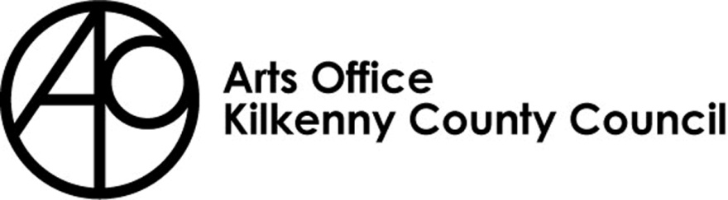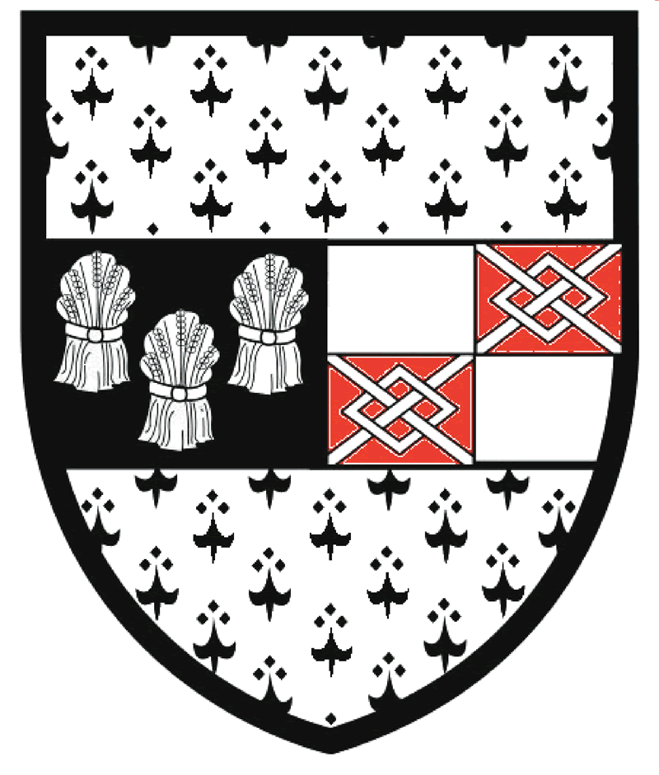

Kilkenny County Council

Arts Office

Tyrone Guthrie Bursary 2023

Return completed applications to:

Mary Butler, Arts Officer

Kilkenny County Council Arts Office,

Johns Green House, Johns Green, Kilkenny

Please mark envelopes ‘Tyrone Guthrie 2023’

Closing date is no later than 4pm Monday 30th January 2023

An independent assessor will award funding on a competitive basis; therefore all applications submitted must be accompanied by documentation/images etc. If you do not provide the relevant documentation/images we will consider your application ineligible.

Tyrone Guthrie Centre Bursary

Kilkenny County Councils Arts Office in partnership with the Tyrone Guthrie Centre is offering a two-week residency at Annaghmakerrig to a practitioner in all art forms.

The practitioner must be currently based in Kilkenny. They will be selected based upon their previous achievements and the project they intend to undertake during their residency. The selected Artist Residency should take place within 12 months of receipt of their award.

The aim of the Residency is to assist and encourage both established and emerging practitioners, to give them an opportunity to work intensively on a ‘project’ alongside others in a very unique environment.

Artists should apply by sending their C.V., samples of recent work and an outline of the project they intend to undertake at the Centre with the completed application form attached.

All successful applicants must acknowledge their funding from the Arts Office on their social media/instagram accounts etc.

Deadline for receipt of applications:
No later than 4pm Monday 30th January 2023

Return to:
Mary Butler, Arts Officer
Arts Office
Kilkenny County Council
Johns Green House, Johns Green, Kilkenny

Please mark clearly as
‘Tyrone Guthrie Bursary 2023’

THE TYRONE GUTHRIE CENTRE at Annaghmakerrig
Address: Newbliss, Co. Monaghan, Ireland
Tel: 00 353 (0) 47 54003
Website: www.tyroneguthrie.ie

THE TYRONE GUTHRIE CENTRE REGIONAL BURSARY SCHEME

Over 27 local authorities in Northern Ireland and the Republic of Ireland are offering special bursary awards to artists born or domiciled in their areas to enable them to spend two weeks at the Tyrone Guthrie Centre at Annaghmakerrig, the artist’s workplace in County Monaghan. The bursaries are administered by each individual local authority.

The Tyrone Guthrie Centre Regional Bursary Scheme has the following objectives:

- To work closely with local authorities and their arts officers to discover emerging and established artists throughout the island of Ireland who might benefit from working at Annaghmakkerig.
- Through the artistic projects they realise to make their work apparent to the local communities from which they come, through exhibitions, performances, readings and other manifestations.
- Through this process to allow the Tyrone Guthrie Centre to establish partnerships with local authorities the length and breadth of the island of Ireland in keeping with its origins and aims as a major cross-border collaboration between northern Ireland and the Republic of Ireland.

NOTES FOR APPLICANTS

The bursaries are open to practitioners in all artforms, born or domiciled within the relevant local authority area. There is no age limit.

Applicants should show significant achievement in their chosen field. This would normally mean that writers should already have published in book form, painters or sculptors should have had one-person shows in reputable galleries and composers or musicians should have had their work commissioned, recorded, performed or whatever might be appropriate to the particular art-form. Otherwise the applicant must demonstrate a high degree of promise attested by references or other forms of support from established figures in the arts.

Each application must be accompanied by a detailed C.V. and a reasonable sample of the artist’s work: 10 slides from visual artists, a book or 20 pages of published work from writers, a recording or score from musicians, and any other supporting material which might be relevant.

Applicants should state clearly what they wish to accomplish during their stay at Annaghmakerrig. This project outline is often decisive and should demonstrate that the artist is working towards an exhibition, publication or performances which will be helped by a stay at the Centre.

Each local authority makes its own preliminary selection from the applications it receives, often calling in expert advice to do so. The closing date for receipt of applications will be determined by each local authority.

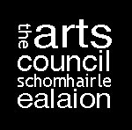 | 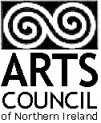  the Tyrone Guthrie Centre  at annaghmakerrig

APPLICATION FOR RESIDENCY

Name: Professional Name:

Art form:

ADDRESS:

EMAIL: TELEPHONE:

Ideal dates of arrival & departure

List your most important publications, exhibitions or performances during the last 3 years.

Give details and venue:

Description of work you will undertake during residency:

References:
Please list the names and addresses of two authorities in your field who know you and your work.

Materials enclosed with this application, i.e., Books, manuscripts, slides, photographs, tapes, scores, press, cuttings or testimonials.

I confirm that I am over 18 and that all of the information I have provided is correct as of the date of signing.

Signature Date…………………
Deadline for receipt of applications:
No later than 4pm on Monday 30th January

Return to:
Mary Butler, Arts Officer
Arts Office
Kilkenny County Council
Johns Green House, Johns Green, Kilkenny
Please mark clearly as
‘Tyrone Guthrie Bursary 2023’

