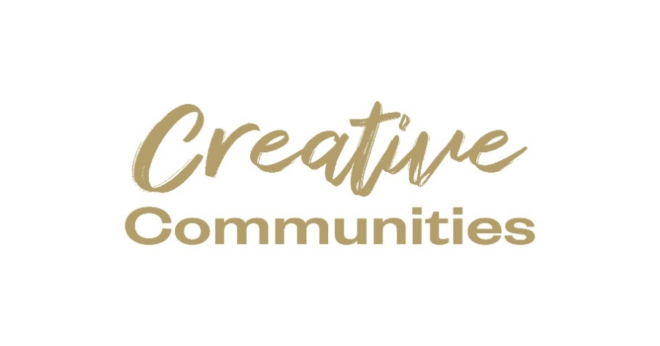

Kilkenny County Council
Creative Ireland
Grant Scheme 2024
Information/Guidance notes
Closing date: Monday 12th of February, 2024 at 4.00pm.
N.B. READ GUIDANCE NOTES PRIOR TO COMPLETING
LATE AND INCOMPLETE APPLICATIONS (SECTIONS NOT COMPLETED/ALL RELEVANT SUPPORTING MATERIALS NOT ENCLOSED) WILL BE INELIGIBLE.

Return completed applications to: creativeireland@kilkennycoco.ie

Community & Culture Section, Kilkenny County Council, Patricks Court, Kilkenny.
Telephone: 056 -7794338 or Email: creativeireland@kilkennycoco.ie

An independent assessment panel will award funding on a competitive basis; therefore, all applications submitted must be accompanied by comprehensive supporting information. If you do not provide the relevant documentation we will consider your application ineligible.
An independent assessment panel will award funding on a competitive basis; therefore, all applications submitted must be accompanied by comprehensive supporting information. If you do not provide the relevant documentation we will consider your application ineligible.

Please note that there is no guarantee of funding for projects that nonetheless may have achieved the minimum criteria. The funding available is limited and eligible applications will be evaluated on a competitive basis.
Creative Ireland Grant Scheme Information and Guidelines

Qualifying project ideas for example: CIRCUS, FILM, LITERATURE, CREATIVE WRITING, MUSIC (all genres), DANCE (all types), STREET ARTS AND SPECTACLE THEATRE, TRADITIONAL ARTS, VISUAL ARTS, CULTURAL, HERITAGE, MULTIDISCIPLINARY ARTS, ARCHITECTURE, PODCASTING, MURALS, AUGMENTED AND VIRTUAL REALITY, FASHION, COMEDY, DESIGN (all kinds), DIGITAL GAMES, CREATIVE DIGITAL TECHNOLOGY, ANIMATION and CODING.

Eligibility criteria for applicants:
- To be eligible for funding, the project must be based in the remit of Kilkenny.
- All initiatives and activities funded from this scheme must adhere to the public health guidance with regard to COVID-19, relevant at the time, as laid down by the HSE and the Government.
- The project must take place in the calendar year in which the money is granted and be completed by Friday, the 11th of October, 2024.
- Eligible applicants will have fully read, understood, and complied with the online Creative Ireland Kilkenny Open Call 2024. This Information Sheet and application form is provided on the Kilkenny County Council website. Click Link: kilkennycoco.ie/eng/search/?q=creative+ireland
- If artists/ creative professionals are engaged in the project, evidence must be shown in the budget of the proposed budget. Artists must have applied for the open call, be garda vetted and approved by KCC.
- Application Deadline with a fully completed application form, fully completed budget, detailed description of your project and all supporting materials and a signed disclaimer form to be submitted by 4pm on Monday, the 12th February 2024; to creativeireland@kilkennycoco.ie.
LATE APPLICATIONS WILL NOT BE CONSIDERED.
- Applicants should NOT contact the Creative Ireland Office after this date. You will be notified by mid-March by email, as to whether you have been successful or not. (Please note your project can not start until you have been notified as to whether you are successful, and this should be considered when proposing your ideas to us. Kilkenny County Council will not retrospectively fund and take no responsibility for proposed projects that have not been awarded funding by due process.
MAKING YOUR APPLICATION - Helpful hints when completing the Grant Application Form/FAQ.
- Applications must be saved as ‘The Title of your project, your Organisations name, Creative Ireland application 2024’ and comprise one PDF document only, which must be no more than 10MB in size.
- All supporting material MUST be included in 1 PDF and attached to ONE email.
- If you do not adhere to the above requirements your application will not be accepted for adjudication
- Before you start filling in the form, read the guidelines and the form from start to finish.
- Make notes and know what documentation is required.
- If you need to get quotes for venues for exhibitions or performances/materials/printed matter (brochures, flyers, posters) etc., get them now and have them got before you start completing the form.
- For visual artists, images of completed work, previous exhibition brochures, etc., should form part of the application.
- When asked for descriptions/purpose etc and the form says Max 400 words please do not exceed this wordcount.
- If you or your organisation has had previous exhibitions/performances, include a sample of historic publicity material with your application i.e. brochures/flyers or newspaper articles for example.
How will the decision on funding be made?

The assessment panel will base their decisions on how the content of the application form and the accompanying documentation meets the criteria, so make sure that all questions are answered and that you have all necessary documentation attached when submitting the application. Funding is limited and eligible applications will be evaluated on a competitive basis. Bear in mind that the assessment panel doesn’t know you or your past work so if you have three or four lines on the form to complete on a particular question, make it matter.

Last, but not least, sometimes, when completing forms, a person can get tunnel vision and could miss an important question or forget to attach the right documentation to the application. Get a friend to have a quick look over the form to make sure that it is clear, concise and meets the criteria.
If I am successful, how do I draw down the funding?

Successful applicants will receive a Letter of Offer along with an acceptance slip. This will form the contract between Kilkenny County Council and the organiser/lead applicant and will detail all conditions and requirements which will include all health and safety requirements by you if appropriate, guidance on GDPR imagery that identifies a person in your images and correct consent forms returned. Full details of all conditions will be emailed to successful applicants.

A list of successful applicants will all be published by Kilkenny County Council and subsequently on Creative Ireland website and social media pages.

In order to receive payment, the successful applicant must provide the following:
- A completed Kilkenny County Council “supplier set up form” with tax registration certification and copy of your bank statement header.
- Evidence that project/initiative/event has taken place (e.g. photographic evidence, MAX 5, high quality jpeg images must be supplied, copies of press features and evidence that on ALL publicity material about your project acknowledge Creative Ireland and Kilkenny County Council with the Logos clearly visible, appear and are acknowledged on all print materials, interviews, films produced and social media postings – (Logos will be supplied to you if successful).
- Receipts for ALL PAYMENTS.
- Payment will be made by Electronic Fund Transfer (EFT) only.
- Failure to return the Part B report and related receipts will forfeit the grant.
- If successful candidates are required to provide a progress report/ Part B form to the Kilkenny Creative Ireland team on/ prior to 11/10/2024.
IMPORTANT CONSIDERATIONS
- If applicants intend to work with children and young people, evidence will be requested if successful of having an up-to-date child protection policy or the child protection policy of your partner organisation.
- Evidence will be requested if applicant is successful for up-to-date Garda Vetting if applicants intend to work with children, young and or vulnerable people, for all adults or persons who you propose to facilitate the workshops.
- Evidence will be requested if applicant is successful for groups/organisations/self- employed individuals/ artists to be Tax compliant, having appropriate Insurances in place and meeting all Health and Safety requirements.
- It is the responsibility of the applicant to ensure that all permissions, approvals, licences or consents needed for your project are secured.
- Kilkenny County Council and Creative Ireland logos should appear on all printed material and be acknowledged on event websites and social media.
- Recipients of the Kilkenny Creative Ireland grant scheme must retain and produce relevant receipts of grant monies for the grant to be drawn down.

GDPR personal data basically means any information about a living person (regardless of age), where that person either is identified or could be identified. It doesn’t have to be in written form, it can also be information about what a data subject looks like, for example an image or photo.
GDPR Guidelines
According to Article 7, the data controller should be able to demonstrate that consent has been given when processing personal data. So, if a living person can be either identified or could be identified, the controller (the Local Authority in this case) should be able to demonstrate that the data subject has consented to the processing of his or her personal data and provide us with same. And it has been flagged with us that once an image, that contains identifiable persons, is uploaded by a Local Authority to the Portal, we then become a joint controller of the data.
Both local and national Government must adhere to the same set of rules and comply with all data protection principles under GDPR.
Where you are unable to provide us with this consent for an image you are uploading to the portal, then don’t use the image, use an alternative.
Event Facilitators:
A consent form is required for all identifiable data subjects (persons) regardless of age. An event facilitator’s consent does not satisfy us that consent has been received from the data subject.
If the facilitator is stating that they have received consent from the data subject, then they should be able to demonstrate that the data subject has consented to the processing of his or her personal data.

Stock Imagery
Stock imagery is fine to use but if we haven’t been informed that the image(s) have been provided from a free sharing image site we will have to return them as we have no way of ascertaining this. A note uploaded to the ‘consent form’ field or you could put it in the ‘other information’ field, would cut down on the need to return them.
You are free to update the image of the event at any stage.

Crowd Shots
Getting consent to take and publish photographs or video of large groups of people can be challenging, for example what do you do if one or two individuals in the group do not give their consent?
When it comes to crowd shots, common sense must prevail. We do not want data protection becoming an obstacle to capturing and celebrating significant public events. Publicise that it’s a public event and that photography or videography may be taken.
For example, where photos are being taken at an event that will appear online and a very large number of data subjects collectively appear in the background of these various photos then it’s reasonable that the Local Authority should be able to publish such photographs or video for these purposes, relying on the legitimate interests legal basis – in other words without having to obtain consent in respect of each person whose image may have been distantly captured in the photo.
If an image has been taken of a crowd at a public event that’s generally acceptable. But if such a photo captured one or two identifiable subjects who were clearly identifiable then consent of the subjects would be a more appropriate basis to publish the image. In other words, taking a photo in public is generally fine; it’s what you do with that photo that can potentially become a data protection issue.
Consent form
You have to be fair to the data subject. The consent form that is used by you should state and let the individual know where and how their data may be used. You do not have to create a second form specifically for the Creative Ireland Programme. You can use your own form, absolutely no problem, but on that form, you need to state where the image may be used. Firstly, by your Local Authority, and secondly that it may be shared and used by the Creative Ireland Programme or the Department of Tourism, Culture, Arts, Gaeltacht, Sport and Media or alternatively by the Government of Ireland.

Imagery
The preference is always to upload an image that is closely associated with the event and not the facilitator. For example, when it comes to, show an image of kids’ reading a book as opposed to who will be reading the book to them. Visually it’s much better and is more appropriate for the audience.

